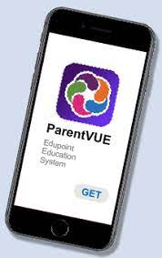
ParentVUE Mobile App
The ParentVUE Mobile app works with the Synergy student information system in much the same way as the ParentVUE web portal. It allows parents to view assignments, grades, attendance, contact information, and more.
Roanoke City Public Schools does not provide support for personal devices. The use of ParentVUE is at your own discretion and risk.
Hardware and Software Requirements:
- Requires a 3G or wireless internet connection.
- Compatible with iPhone, iPod touch and iPad and requires iOS 12.0 or later.
- Requires Android 2.2 and up.
- ParentVUE mobile app uses the same user login as the web based ParentVUE portal.
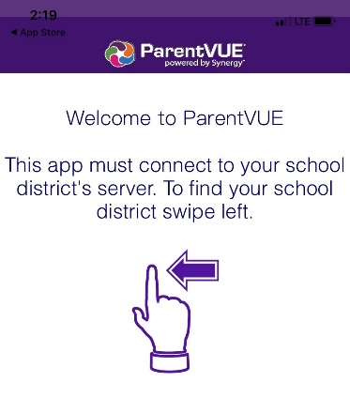
- Download and install the mobile application.
- After launching the mobile app for the first time you will need to connect to your child’s school district. On the Welcome to ParentVUE screen, swipe left.

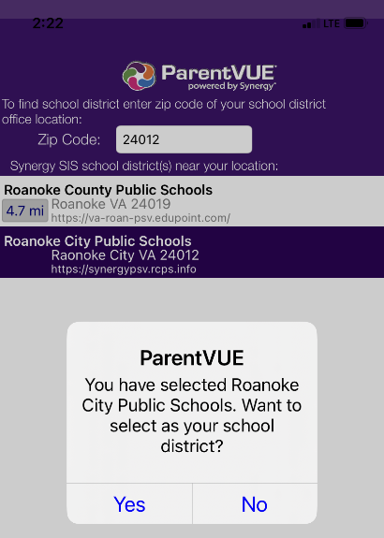
- A message displays asking you to enable location services on your device.
  - Press Allow to automatically display a list of school districts near your location.
  - Press Deny to search by zip code or manually enter the school district URL.

htps://va-roc-psv.edupoint.com/PXP2_Login.aspx
- To search, enter the Roanoke City Public School zip code (24012) and select the Search button. Scroll through the list and select the desired school district.

- After making a selection, you will be prompted with a message asking, “Would you like to set this as your School District?” Tap Ok.
- You may be presented with a dialog stating, “To login you will need to activate your account.” Select Yes to begin the account activation process.
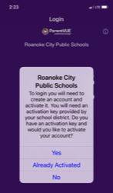
  - If you do not see this message, you can select the “Have activation key? Create my account” option below the Login button on the main menu.
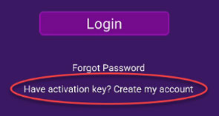

Activating your ParentVUE Account
Activation Key Letter
You should have received an Activation Key Letter from your child’s school. This will include, at minimum, your first and last name as they have been entered into the system, and the Activation Key.
Navigate to ParentVUE
On a Computer Browser: From the ParentVUE sign-on screen, select the “More Options” button to expand the menu, then select the “Activate Account” option.
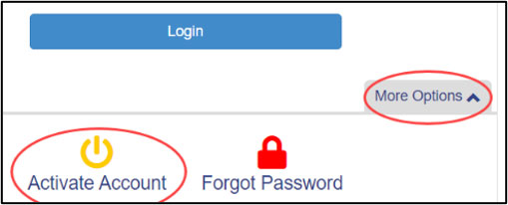
On a Mobile App: select the “Have activation key? Create my account” option below the Login button on the main menu.
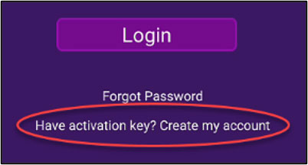
Parent Account Activation Step 1 of 3:
Read through the Privacy Statement, clicking “I Accept” if you agree.
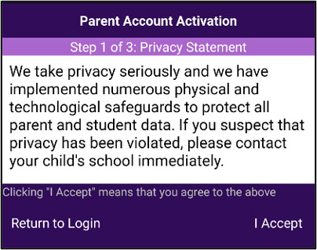
Parent Account Activation Step 2 of 3:
Enter your First Name, Last Name, and Activation Key as they were given to you.
Parent Account Activation Step 3 of 3:
- Enter a User Name to be used for logging into your ParentVUE account.
- Create an account password at least 6 characters in length.
- Enter your primary email address that can be used to receive ParentVUE alerts and for resetting your account password in case you forget it.
- Select the “Complete Account Activation” button to create your account and to be able to log into ParentVUE for the first time.
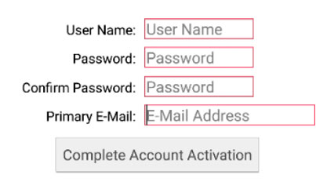
Please contact your child’s school if you are having any difficulty accessing your ParentVUE account.
"
"

